Affordable drone education platform

September 10, 2016

Authors: Sundaramahalingam Sudharshan, Isaac Tay Eng Hian, Ambrose Chua, Prahlad Vadakkepat

# Introduction

The Unmanned Aerial Vehicle (UAV), commonly known as a drone, industry has seen a market growth from a 552 million USD industry in 2014, to 1.4 billion USD in 2015 with an expected forecast of 5 billion USD by 2017.[1] Drones are being applied to practical uses in agriculture, surveillance, security and industrial automation. One application of drones is a military attack platform where the industry is estimated to reach 1.8 trillion by 2017.[2] Another application is in the agriculture industry through monitoring of crops, large plantations and vegetation.[3] Specialized applications include mosquito vector control[4] and oil spill detection monitoring[5].

Drones are increasingly being used as a platform for robotics research, secondary and higher education.[6]  Drones are suitable to facilitate learning especially in robotics, control systems, embedded system engineering, artificial intelligence and systems engineering.[7] Additionally, they could be used to teach concepts like Bernoulli’s principle, stall speed, practical circuitry, fluid dynamics, and projectile motion to secondary education students.

Quadrotor helicopters or quadcopters are currently the most common drone platforms available. They operate on the mechanics of 4 rotors spinning at varying velocities which allows the drone to achieve steering and thrust through a PID loop based control system. [8]  These quadcopters are unaffordable in large quantities for integration into schools. Quadrotor platforms also have exposed rotors which raises safety concerns for use in schools. Although these platforms have free APIs, the hardware is closed-source making it hard for students to explore and delve into hardware based topics using these platforms.

An affordable and open architecture drone, namely SentiBot, is detailed in this work. SentiBot utilizes a dual-propeller electronic ducted fan (EDF) with an enclosed frame in a coax-copter design. The design increases safety while decreasing the cost and enables high modularity. The frame is 3D-printed which allows easy hardware replication for experimentation to be conducted with additional sensors. The platform has the Intel Edison System on a Chip (SoC) and a unique dual CPU architecture which enables compartmentalization of computational tasks. [9] The higher level tasks are managed by the Intel Edison CPU while the lower level real-time tasks are handled by the ATMEGA 328 8-bit microcontroller running a real time operating system (RTOS). The platform utilizes Yocto Linux and supports ROS which provides open source libraries and software resources. [10]

# SentiBot hardware design

## Safety, affordability and accessibility of educational platform

The concern with drone safety has resulted in the stringent regulation by governments on the usage of drones in public and in industries. [11] The safety of the drone is thus critical. A lower cost drone platform allows a greater adoption rate by schools as budget cuts faced by schools is impacting adoption of a technology based curriculum [12]. Robotics platforms used in education need to provide easy access to hardware and software systems to enable students to learn through experimentation. [13] The three aspects of an education drone platform is summarized as safety, affordability and accessibility.

## Modular, 3D printed drone frame design

#### The Sentibot uses a novel frame design which is made through additive material fabrication using a Nylon-6 filament as Nylon-6 provides a high durability to weight ratio which is favorable for a flying platform.[14] The novelty of the design is that the electronics in housed outside of the main body in contrast to the internal housing seen in other coax copters.[15] Having the electronics outside the main body enhances the accessibility of the electronics components.

A modular frame design based on support beams holds the frame together. The frame is designed in a cylindrical form as the compressive strength of cylinders has been shown to be superior of cuboids due to lack of discrete stress points like the corners of a cuboid [16] A two-part motor assembly is used to enclose 2 counter-rotating rotors which creating a ducting effect. The ducting of the motors increases efficiency at high rotary speeds and also enhances the static thrust performance of the system. [17]

## Control system and steering

Control and steering is accomplished through 4 thrust vectoring vanes manipulated by 3.3g 5v servos. Such a configuration is typical of other coax-copters as well. [15] The vanes are housed within protective housing to minimize damage during a collision. The servos are housed inside the frame with access panel doors to enabling replacement of damaged components. The frame encloses all moving components and aids in increasing the safety of using the platform.

## Motor-Propeller combination

By spinning counter-rotating bullnose propellers using a 4000kV race quad motor, the SentiBot can achieve a high thrust to space ratio. Performance analysis of propellers show that larger diameter propellers are more efficient as compared to smaller propellers. [18] The SentiBot uses 2 large rotors arranged in a stacked configuration as compared to a quadrotor which uses 4 smaller propellers arranged in a plane thus higher efficiency can be obtained from the SentiBot.[18] This allows for a compact frame design while preserving the payload carrying capacity.

## Usage of a coaxial dual-motor thrust design

Experiments were conducted to determine the motor configuration that would be the most ideal. 3 unique configurations where chosen for testing. Configuration A uses a single 4000kv Electronic Ducted Fan (EDF). Configuration B utilizes a single 4000kv Racing Quadcopter motor which is spinning a 3040 triple blade propeller. Configuration C uses 2 4000kv motors spinning the same 3040 triple blade propeller stacked vertically with an inter-propeller distance of 8cm. Configuration C is significant as it accounts for the counter-torque effects produced by the motor and offers a method to cancel the effects unlike the preceding configurations which require active compensation from the control surfaces.

Each of these configurations, were tested by measuring the thrust output and current consumption and taking the average of 10 measurements. These results allow computation of the efficiency and maximum thrust output provided by each configuration. Given the battery capacity, flight time expectations and the mass of the SentiBot, the ideal configuration for the SentiBot can be determined.

|  |  |  |
| --- | --- | --- |
| Configuration | Maximum Thrust/g | Maximum Current/A |
| A | 200 | 18 |
| B | 250 | 13 |
| c | 450 | 23 |

## Jointed control surfaces

Initially, 4 servos were utilized to manipulate 4 independently movable control surfaces. Each servo weighs 3.3g and the duplicated, redundant control surfaces adds to the weight of drone. The removal of 2 of the servos, requires the control coupling of the 2 adjacent control surfaces which could lead to the loss of the additional yaw authority provided by independent control surfaces. The double motor configuration allows for enough yaw authority, so the adjacent control surfaces were coupled together using a jointed control surface design.

## Motor mounting struts

The motor mounting struts where initially flattened on the positive Z-axis which resulted in the impedance of air flow resulting in loss of motor efficiency. Thus, the design was improved such that the motor-mounting strut is flattened on the positive X-axis which gives the strength and rigidity required of a motor mount while preventing air-flow impedance through the frame.

## Aerodynamic analysis of the frame

The frame underwent aerodynamic analysis to determine the efficiency and drag co-efficient of the frame. Through this analysis, the frame can be ensured to be streamlined and to allow for efficient movement during operation. It additionally allows for a higher speed during flight.

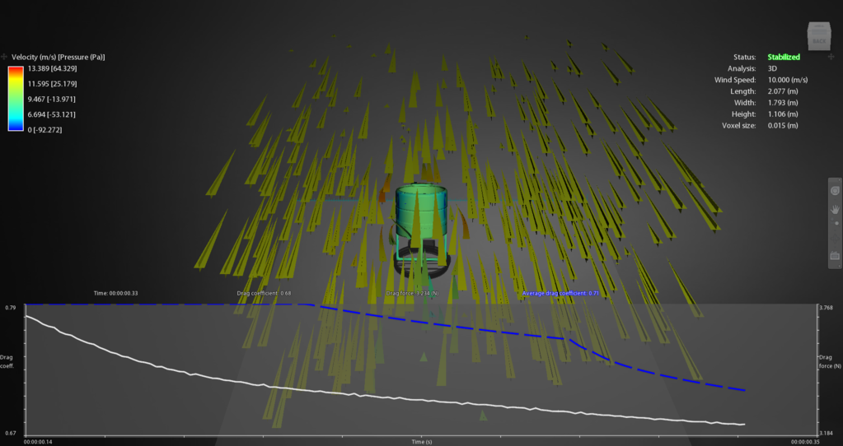

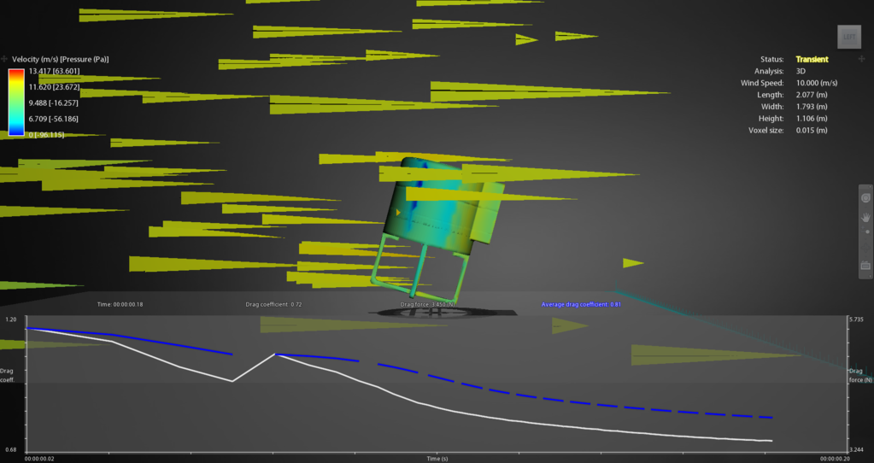

The aerodynamic analysis of the frame shows that due to the cylindrical frame design, the body is minimized. During forward motion, the drag primarily arises from the electronics compartment but it is considered negligible as the craft is too small for these effects to manifest in a significant manner. The one-sided nature of the electronics compartment results in the loss of radial symmetry which gives rise to some instability but the software mechanisms have been designed and tuned to compensate for these errors.

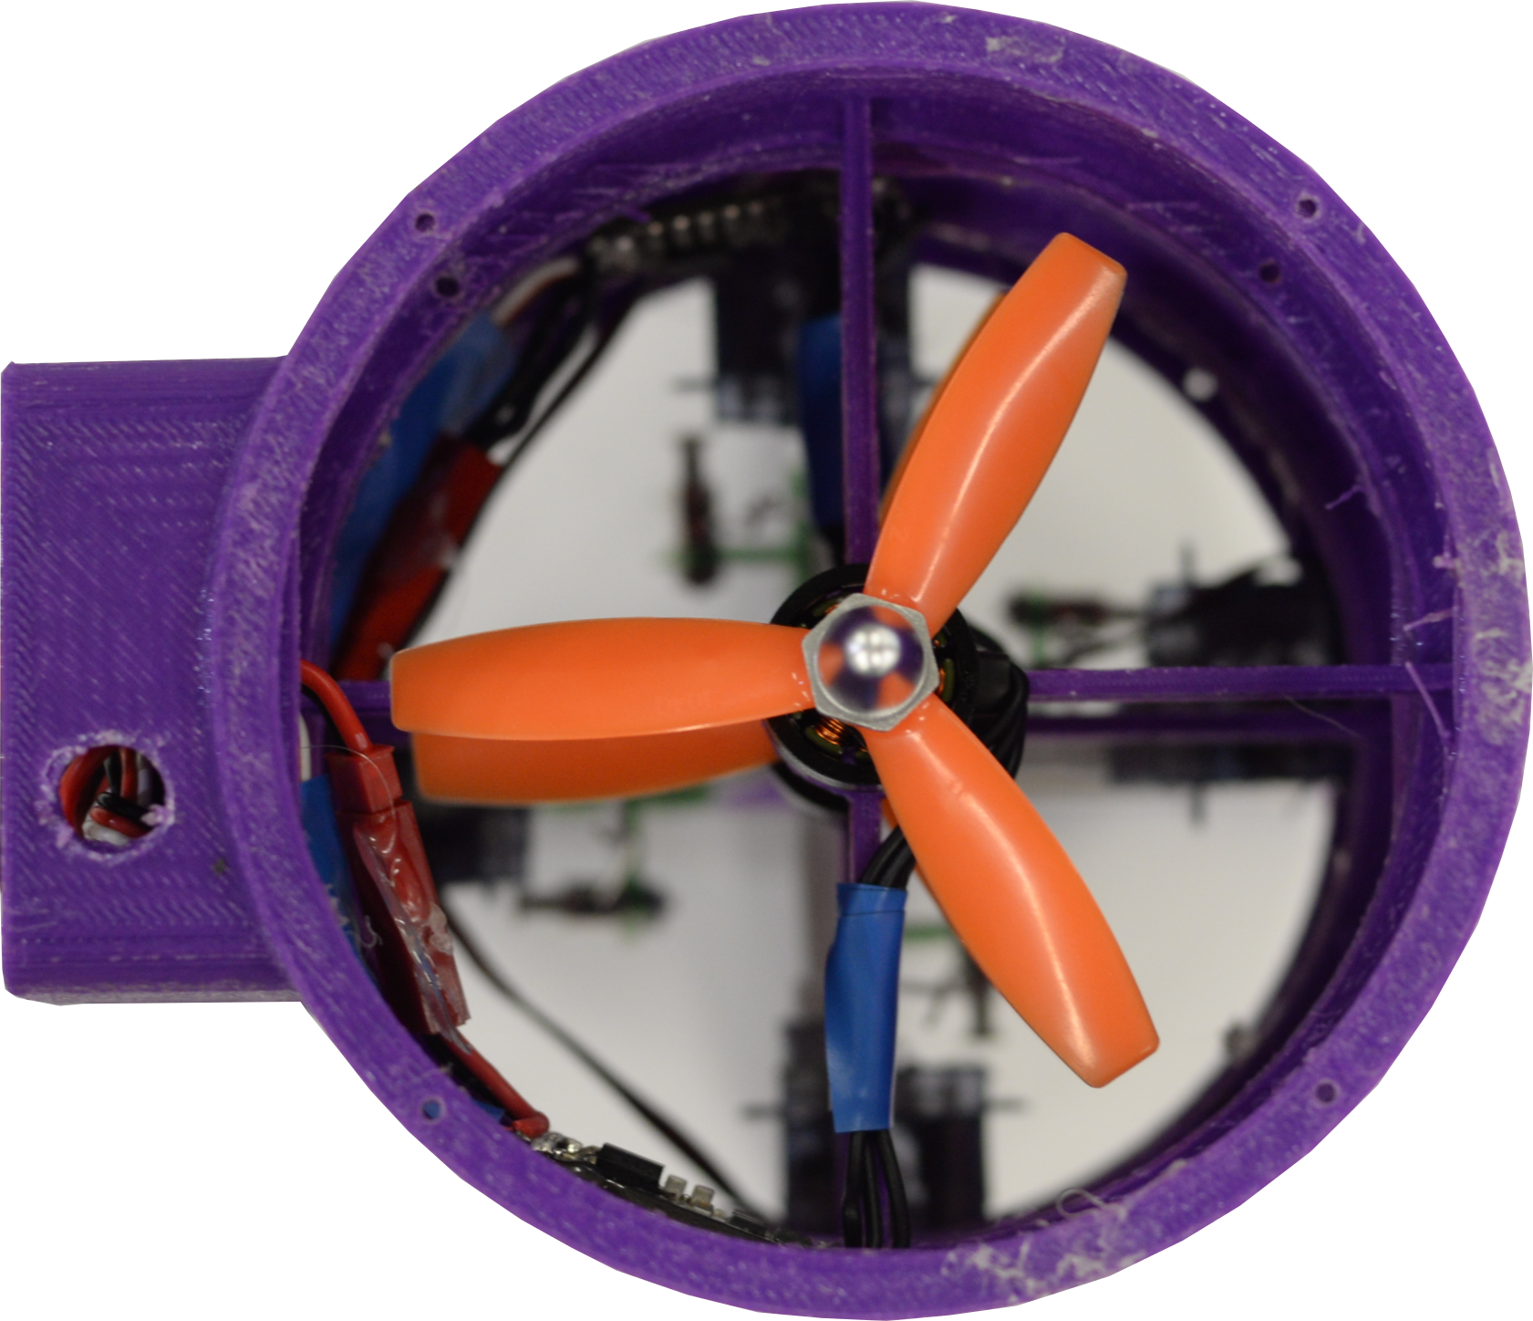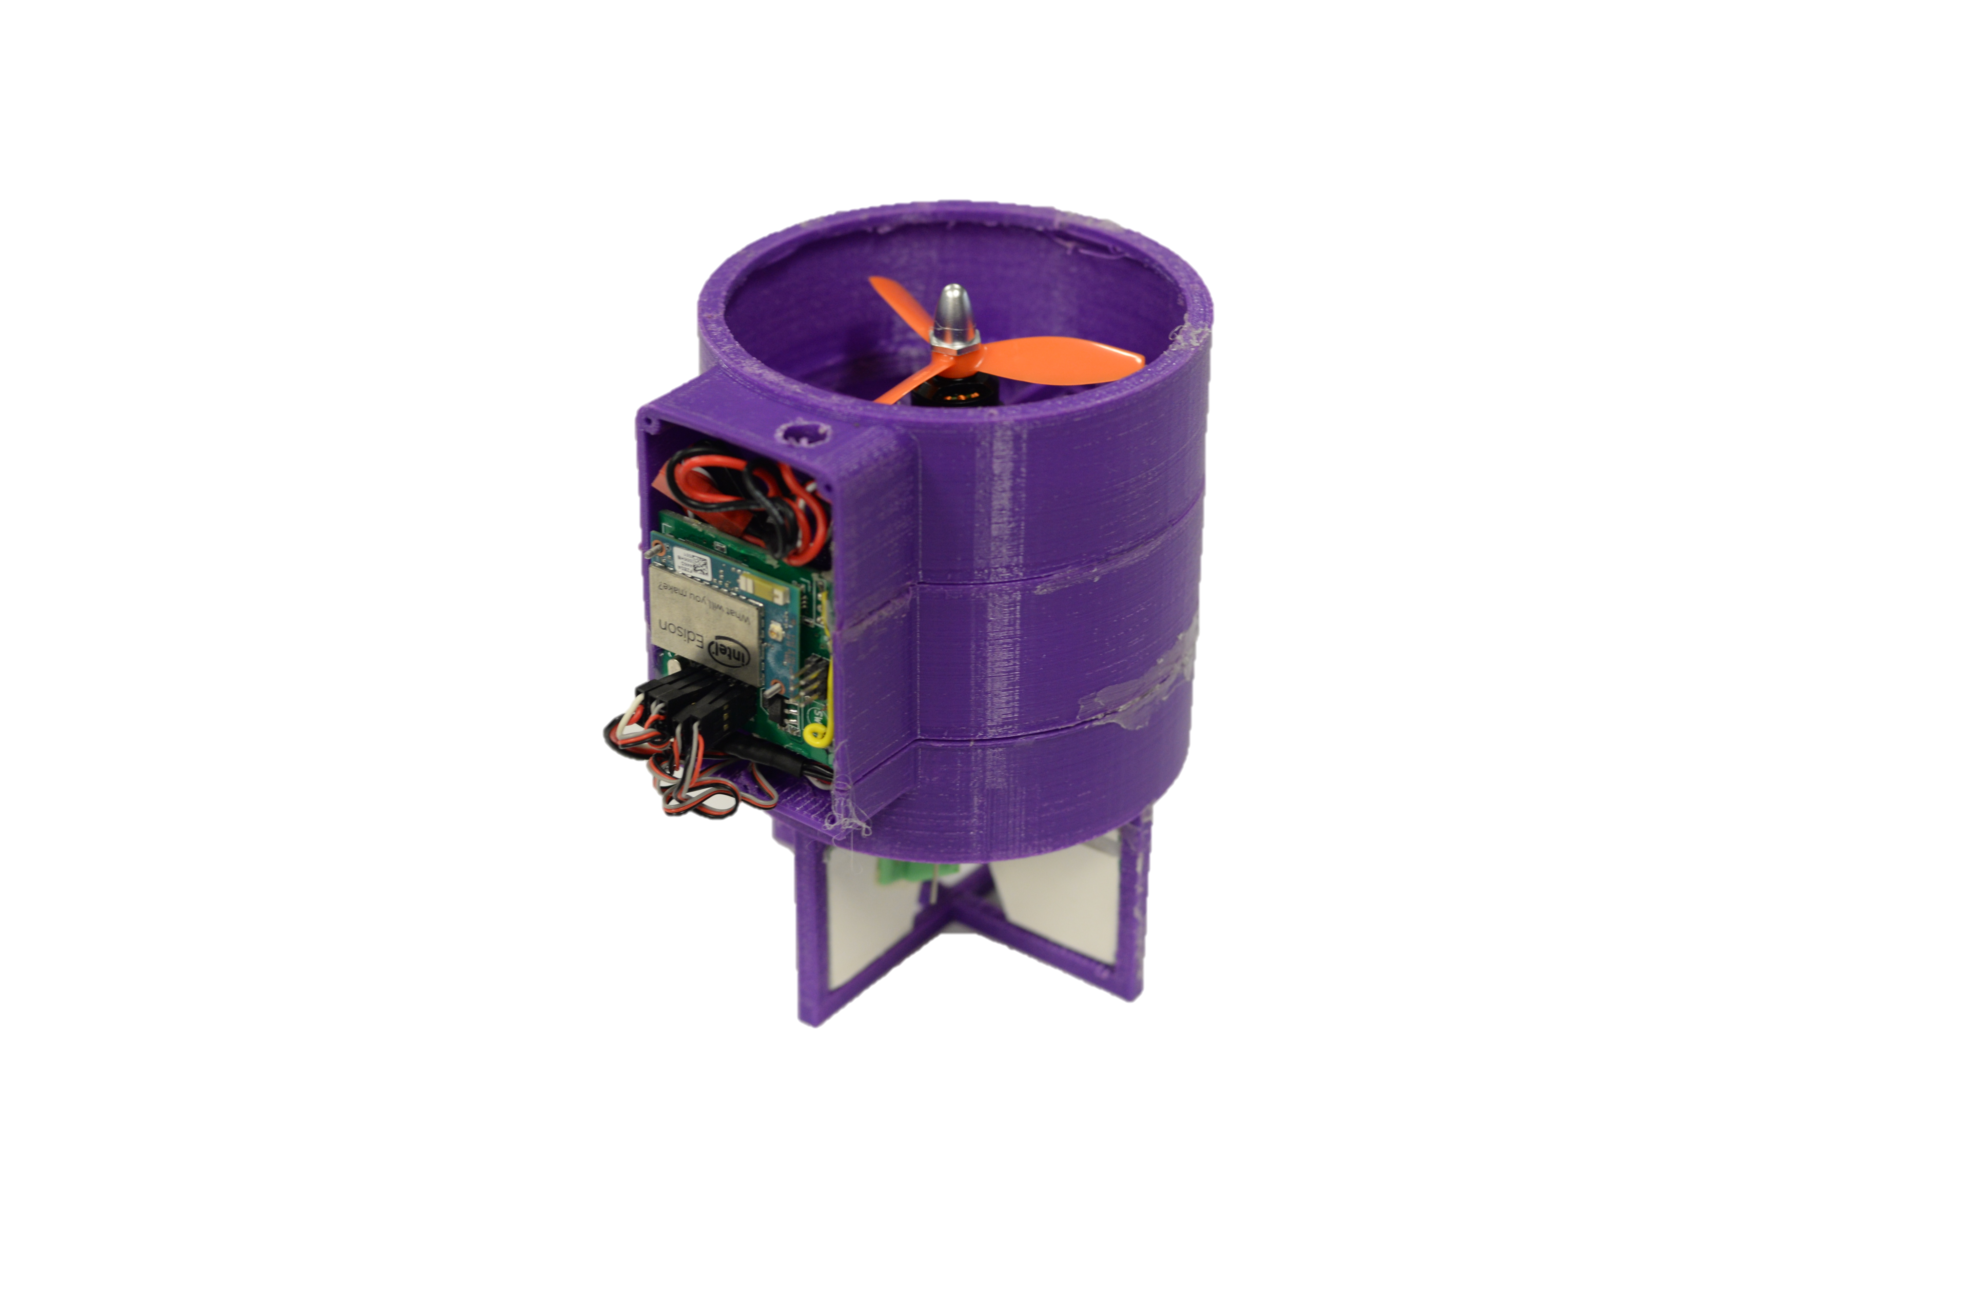

**Figure 2: Image of the functional SentiBot platform (Top-Down view)**

**Figure 1: Image of the functional SentiBot platform (Perspective View)**

# 

# SentiBot Electronics Design

## Main Processor

**Table 2: Hardware components of the drone platform**

Component Hardware

Main Processor Dual core 500Mhz Intel Atom

Secondary ATMEGA 328

Processor

Motors 4000KV motors

ESCs 12A XMS series

Batteries 800mAh 4S(14.8v)

Propellers 3x3x4.5

Servos 2.8g ultralight

Thrust 500g

Weight 250g

There arises a need for a powerful onboard processor as computing power intensive tasks cannot be offloaded to a ground-station when research involving untethered navigation, distributed robotic systems and swarm robotics [19] is being conducted. Vision processing and autonomous navigation also are very computationally intensive. [20] The SentiBot has an Intel Edison SoC which consists of a 500Mhz Intel Atom, an Intel Quark microcontroller (MCU), 1GB of onboard DDR3 RAM and 4GB of onboard flash storage. [21] which enables the platform to do these tasks.

## Dual CPU architecture

The Intel Edison is suitable for use as a microprocessor but cannot operate in real time thus it is unable to generate control signals for servos and the motor. By using an additional ATMEGA 328, the platform gained additional sensor expandability options through getting more general purpose input-output(GPIO) pins and the ability to operate in a RTOS. A custom 2-layer PCB was designed and fabricated to combine these 2 processors together to get a dual-CPU architecture. Tasks that are more complex are executed in the Intel Edison while time-critical tasks like communication with sensors and actuators are done in the ATMEGA 328. The separation of the higher and lower level processing also provides code organization in the software.

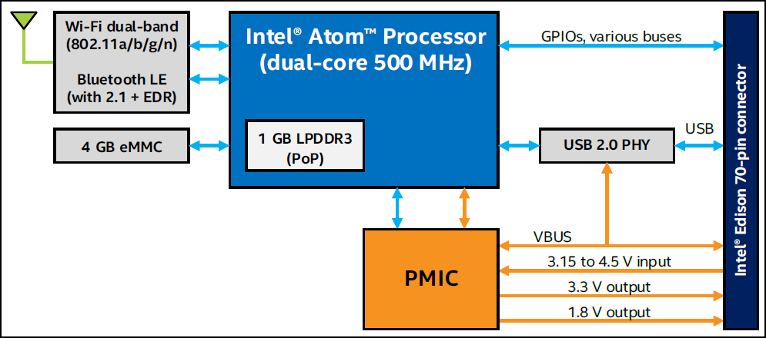

**Figure 3: Hardware peripheral system of Intel Edison**

## On board sensors

The main sensor which allows for the drone to fly in a stable manner is the Inertial Measurement Unit (IMU). This sensor provides accelerometer and gyroscope information to the secondary processor for the PID loop to keep the drone upright. The sensor also allows for dead reckoning to be used for localization. [22] The IR distance sensors mounted on all 4 sides allows for collision avoidance to prevent crashes. There is also an onboard RGB camera which interfaces to the primary processor over USB.

## Flight Drive system specifications

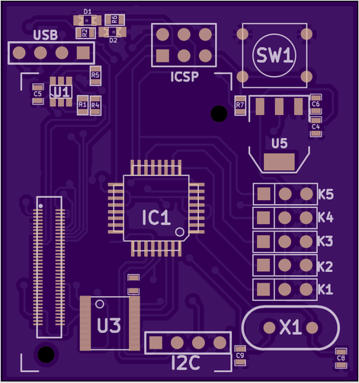The power electronics consists of 4 1C 1200mAh batteries, 2 30A super light ESC’s and 2 4000kV 1306 motors. The motors have a max current draw of 8A each and taking into consideration that the max thrust of each motor is 370g the gram per current rating for each motor is 46g/A. Since the weight of the SentiBot is about 320g, the nominal current draw during a hover would be about 7A. That gives a flight time of about 10-15 minutes.

## Power Supply management

In terms of power management, 3 voltage levels are required- 14.8V from the battery, 5V for the control board and 3.3V for the control circuity. Since the drone’s ESCs do not come equipped with a built in battery eliminator circuit (BEC) an external switching regulator is used to supply clean 5V for the control board. The onboard 3.3V LDO further steps down the voltage from 5V to 3.3V

**Figure 4: Edison-ATMEGA328 Dual CPU PCB**

# Software Design

Good hardware needs to come with good software. By ensuring modularity and modifiability, the platform will be education-friendly. SentiBots has two methods of operation: manual and autonomous. In manual, an operator has full control and information from the drone. Operated autonomously, the drone is user-programed to complete tasks with little or no human intervention. SentiBots has two subsystems: control and intelligence. The control subsystem consists of the hardware interface to GPIO and the IMU, and relevant PID loops. It also can provide basic obstacle avoidance. The intelligence subsystem is for complex tasks like navigation, localization, vision, object identification and other tasks for autonomous flight. It also provides communication with the groundstation.

## Lower level subsystem

The control algorithm in SentiBot is standard. Sensor data is mapped into error values that can be used to compensate for frame errors and instabilities. IMU data (processed by an internal DSP) is read over I2C to obtain yaw-pitch-roll (ypr) data. Each ypr value is used in PID loops for each axis to obtain error values. The angle of the control surfaces are set by the error values, therefore stabilizing the system. This computation runs on the ATMEGA 328.

As shown in *Figure 3,* A I2C peripheral interface is used between the lower level subsystem and the Inertial Measurement Unit (IMU). A USART interface is used between the microcontroller and the processor running the higher level subsystem. This communication is managed by software that utilizes the Multi-Wii protocol. [5]

The firmware which runs the lower level subsystem is based on the open-source Multi-Wii project. Minor modifications were made to the firmware for coax-copter support but the built-in Multi-Wii PID loop controller and communication infrastructure were used. The open-source Multi-Wii framework is modular and easy to modify for the end user. The Multi-Wii platform is also well documented and easy to understand. The lower level subsystem carries out basic collision avoidance system with 4 IR sensors installed around the bot. This prevents higher level algorithms from allowing crashes and damage to the bot and the environment. This is done through a modification that is made to the Multi-Wii framework which adds collision avoidance functionality to it.

## Higher Level subsystem

The autonomy of the SentiBots, when implemented in a fully modular manner, allows students to tap onto resources available online and libraries for implementing autonomy in the SentiBots. Thus, the SentiBots is based on the ROS architecture which is completely open source and provides existing libraries for students to easily implement systems into the robots. The ROS architecture is already used by students and researchers.

The communication system is reliant on the onboard WiFi chipset present in the Intel Edison SoC. It connects to an 802.11n network operated by the ground station and transmits over the established network. It also transmits telemetry information gathered from hardware through the microcontroller and sensor expansion port.

## screenshot_2016-03-07-20-10-03_ioGround-station software

We are currently still in the process of designing and implementing the ground-station. However, we have developed a method to control it through an android app. It uses a simple UDP interface and connects to the Edison via Wi-Fi which allows instructions to be issued to the SentiBot. Lately, a Spektrum satellite receiver has also been added to the spare UART2 port for longer range and lower latency.

**Figure 6: Screenshot of the android app**

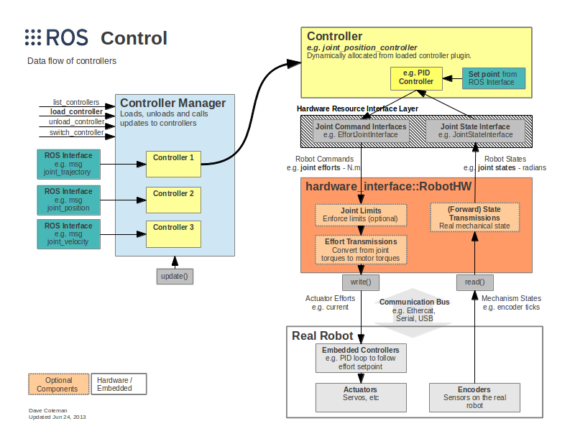

**Figure 7: Standard ROS based architecture [6]**

# Results

The results of initial testing were positive. The SentiBot shows the ability to lift off, and fly in a stable hover with minimal user intervention. When moved around, the SentiBot platform can accurately maintain its attitude without much user compensation. Furthermore, the drop tests were significantly positive showing that the SentiBot can survive drops from up to 3m high due to its rigid 3D printed PLA frame. These drop tests were conducted through flying to robot up to a certain height and removing power from the motors and measuring how high we could drop from before there was damage to the frame. Only one test run was conducted. In testing, the top speed achieved from the SentiBot is also about 20km/h and flight times are about 15 minutes with normal flying. Furthermore, the SentiBot is able to achieve versatile flight through, under and over several obstacles without any problems due to its small size and form factor. The SentiBot can also easily take collisions with walls or other obstacles without falling due to its shell.

# Conclusion

The SentiBot project set out to bring an extremely safe, easy to use and cheap drone for use in educational institutions around the world. It aimed to solve some critical issues in bringing consumer drones to educational institutions for use in student interaction and learning processes by making an ideal drone platform that caters to the cost, ease of use and safety issues presented in those consumer drones. We have created that platform in SentiBots. The competitive pricing with consumer drones while providing one the safest and most hackable drones in the world today makes it highly suitable for educational institutions ranging from secondary schools to tertiary institutions and universities.

Some future work could be conducted into more detailed software which can complement the SentiBot hardware platform as software support for coax-copters in the world today is very limited and rudimentary.

# 

# References

[1]- Završnik, A. (n.d.). Drones and unmanned aerial systems.

[2]- Kreps, Sarah, and Micah Zenko. "Next Drone Wars; Preparing for Proliferation, The." *Foreign Aff.* 93 (2014):

[3]- Green, Miranda. "Unmanned Drones May Have Their Greatest Impact on Agriculture." *Daily Beast* (2013).

[4]- Amenyo, John-Thones, et al. "MedizDroids Project: Ultra-low cost, low-altitude, affordable and sustainable UAV multicopter drones for mosquito vector control in malaria disease management." *Global Humanitarian Technology Conference (GHTC), 2014 IEEE*. IEEE, 2014.

[5]- Aznar, F., Sempere, M., Pujol, M., Rizo, R., & Pujol, M. J. (2014, March). Modelling oil-spill detection with swarm drones. In *Abstract and Applied Analysis* (Vol. 2014). Hindawi Publishing Corporation.

[6]- Mataric, Maja J., Nathan P. Koenig, and David Feil-Seifer. "Materials for Enabling Hands-On Robotics and STEM Education." *AAAI spring symposium: Semantic scientific knowledge integration*. 2007.

[7]- Winterfeldt, Götz, and Christina Hahne. "Controlling quad-copters a project-based approach in the teaching of application design." *2014 IEEE Global Engineering Education Conference (EDUCON)*. IEEE, 2014.

[8]- Uyar, Ekrem Bilgehan, İsmail Uyanık, and Ömer Morgül. "Implementation and Control of an Open Source Quadrotor Platform."

[9]- Pedretti, D., et al. "CUSTOM HARDWARE PLATFORM BASED ON INTEL EDISON MODULE." (2015).

[10]- Wiki.ros.org. (n.d.). *ros\_control - ROS Wiki*. [online] Available at: http://wiki.ros.org/ros\_control [Accessed 9 Oct. 2016].

[11]- Luukkonen, Teppo. "Modelling and control of quadcopter." *Independent research project in applied mathematics, Espoo* (2011).

[12]- Cbpp.org. (2016). *Most States Have Cut School Funding, and Some Continue Cutting | Center on Budget and Policy Priorities*. [online] Available at: http://www.cbpp.org/research/state-budget-and-tax/most-states-have-cut-school-funding-and-some-continue-cutting [Accessed 16 Oct. 2016].

[13]- Jamaluddin, Musa. "Flying Robot Surveyor (To Build FRS Hardware and Remote Control Design with IP Camera)." (2013).

[14]- Kojima, Yoshitsugu, et al. "Mechanical properties of nylon 6-clay hybrid."*Journal of Materials Research* 8.05 (1993): 1185-1189.

[15]- Phys.org. (2011). *Japanese inventor develops flying sphere drone*. [online] Available at: http://phys.org/news/2011-08-japanese-inventor-sphere-drone.html [Accessed 9 Oct. 2016].

[16]- Del Viso, J. R., J. R. Carmona, and G. Ruiz. "Size and Shape Effects on the Compressive Strength of High Strength Concrete." *6th International Conference on Fracture Mechanics of Concrete and Concrete Structures*. 2007.

[17]- Mort, Kenneth W., and Paul F. Yaggy. *Aerodynamic characteristics of a 4-foot-diameter ducted fan mounted on the tip of a semispan wing*. No. NASA-TN-D-1301. NATIONAL AERONAUTICS AND SPACE ADMINISTRATION MOFFETT FIELD CA AMES RESEARCHCENTER, 1962.

[18]- Merchant, Monal P., and L. Scott Miller. "Propeller performance measurement for low Reynolds number UAV applications." *AIAA* 1127 (2006): 2006.

[19]- Ma'sum, M. Anwar, et al. "Autonomous quadcopter swarm robots for object localization and tracking." *Micro-NanoMechatronics and Human Science (MHS), 2013 International Symposium on*. IEEE, 2013.

[20]- Bertozzi, Massimo, Alberto Broggi, and Alessandra Fascioli. "Vision-based intelligent vehicles: State of the art and perspectives." *Robotics and Autonomous systems* 32.1 (2000): 1-16.

[21]- Intel Edison Product Brief. (2016). 1st ed. [ebook] Intel. Available at: http://download.intel.com/support/edison/sb/edison\_pb\_331179002.pdf [Accessed 16 Oct. 2016].

[22]- Kleeman, Lindsay. "Optimal estimation of position and heading for mobile robots using ultrasonic beacons and dead-reckoning." *Robotics and Automation, 1992. Proceedings., 1992 IEEE International Conference on*. IEEE, 1992.

[23]- Phys.org. (2011). *Japanese inventor develops flying sphere drone*. [online] Available at: http://phys.org/news/2011-08-japanese-inventor-sphere-drone.html [Accessed 9 Oct. 2016].

[24]- GitHub. (n.d.). *MultiWii*. [online] Available at: https://github.com/multiwii [Accessed 9 Oct. 2016].

[25]- Wiki.ros.org. (n.d.). *ros\_control - ROS Wiki*. [online] Available at: http://wiki.ros.org/ros\_control [Accessed 9 Oct. 2016].

[26]- Jamaluddin, Musa. "Flying Robot Surveyor (To Build FRS Hardware and Remote Control Design with IP Camera)." (2013).